ADVENTURE WORKS · TECHNICAL SUPPORT

Bent Derailleur Hanger and Poor Shifting
Drivetrain Document TS-016 Rev. A
Applies to | All geared Adventure Works models
Difficulty | Intermediate – Advanced
Time required | 20 – 45 minutes
Tools needed | Derailleur hanger alignment gauge, Hex keys, Spare hanger (recommended)

Symptoms
- Shifting is poor across all gears even after indexing.
- The chain shifts unevenly going up vs. down the cassette.
- The rear derailleur looks angled inward toward the wheel.
- Shifting got worse right after the bike fell on its drive side.
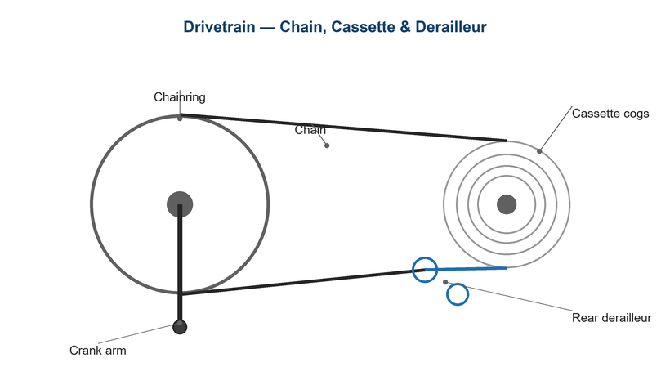
Figure 1. The hanger holds the rear derailleur in precise alignment with the cassette.

Likely Causes
- A bent derailleur hanger (the sacrificial bracket between frame and derailleur).
- Impact from a crash, fall, or transport knock.
- A previous over-shift driving the derailleur into the spokes.
- A loose or damaged hanger bolt.
- A bent derailleur cage (separate from the hanger).
Safety first
- Never shift into the largest cog if the hanger may be bent toward the spokes — the derailleur can enter the wheel.
- The hanger is designed to bend or break to protect the frame; don't force a badly bent one straight repeatedly.
- Check alignment before any hard riding after an impact.

Customer Fix — Step by Step
Suitable for home repair with basic tools. Work through the steps in order.
- Sight from behind the bike: the rear derailleur and its jockey wheels should sit vertically, parallel to the cassette cogs.
- If the derailleur leans toward the wheel, the hanger is likely bent.
- Carry and fit a spare hanger if you have the correct model — replacement is more reliable than bending.
- After fitting a straight hanger, re-index the rear shifting (see TS-004).
- Test shifts in a safe area, paying attention to the largest cog for clearance.
- If shifting is still off, alignment should be checked with a gauge (technician step).

Technician Reference
Additional checks and adjustments for service technicians and advanced users.
- Thread a hanger alignment gauge into the derailleur mount and measure the rim gap at multiple clock positions.
- Gently correct the hanger so the gap is equal all around (alloy hangers can be bent back; replace if cracked).
- Confirm the correct hanger model — hangers are frame-specific.
- Re-set limit screws, B-tension, and cable indexing after alignment.
- Inspect the derailleur cage and pulleys for damage and replace if bent or worn.

Torque & Specifications
Fastener / setting | Specification
Hanger bolt(s) | 4 – 6 N·m
Derailleur mount bolt | 8 – 10 N·m
Alignment target | Equal rim gap all positions
B-screw gap | 5 – 6 mm
Hanger type | Frame-specific — match exactly

Figure 2. A bent hanger tilts the derailleur and ruins indexing in every gear.
Pro tips
- Keep a spare hanger for your exact frame — it's the cheapest insurance against a ruined ride.
- After any drive-side fall, check hanger alignment before forcing a shift.

When to Visit a Service Center
- You don't have an alignment gauge or the correct spare hanger.
- The hanger is cracked or the threads are damaged.
- The derailleur body or parallelogram is bent.
- Shifting remains poor after alignment and re-indexing.
This guide is provided for reference. Torque values are typical starting points — always follow the specific component manufacturer's instructions. © Adventure Works.

